Linux User Administration, Group Configuration, and Access Control
Requirements
- User Management: Create a Linux user named sivaranjani and verify successful login.
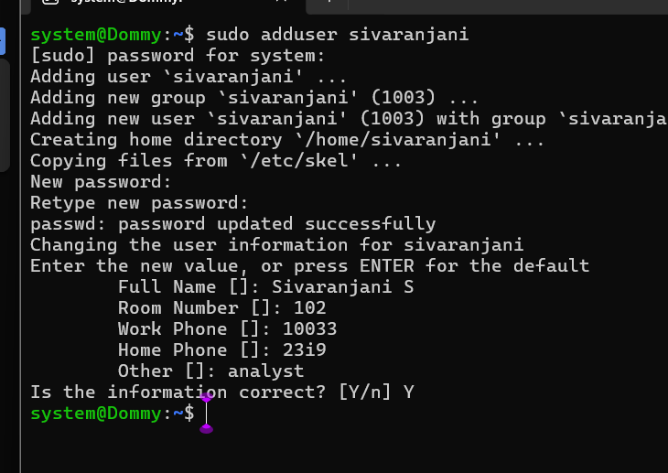
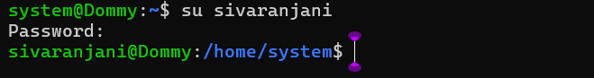
- Group Management: Create a group named admins, add sivaranjani to the group, and verify group membership.
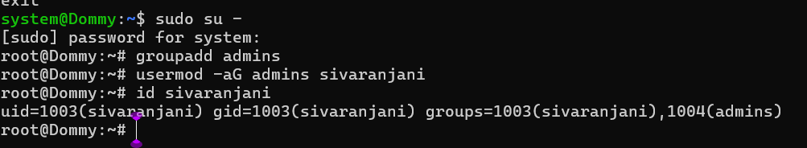
- File and Directory Management: Create a file named data.txt and a directory named sharedfolder.
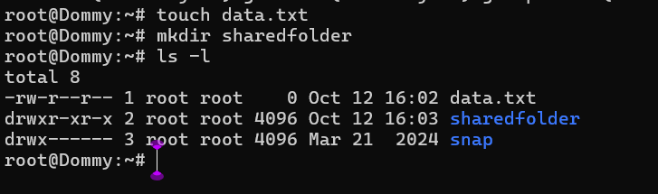
- Ownership Management: Change the owner of data.txt to sivaranjani and its group to admins. Assign the appropriate owner and group to sharedfolder.
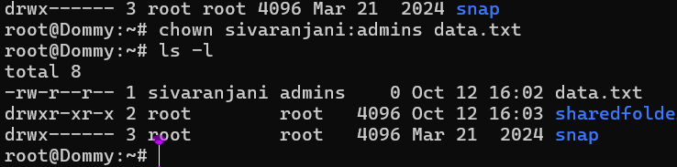
- Permission Management: Set the file permissions to allow the owner to read and write, the group to read, and others to read. For the directory, grant write permission to the group and write and execute permissions to others.

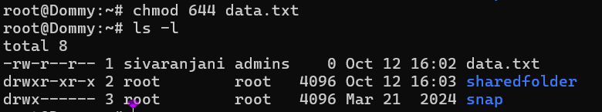
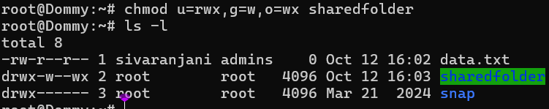
- Verification: Verify user details, group membership, file and directory ownership, and the final access permissions.

